**ER Modelling Exercise – Hospital**

Consider the following requirements for inpatients at a hospital:

All patients admitted to the hospital are given a unique patient number. The patient’s name, address, age, and sex are recorded. Private patients are allocated a private room, identified by the room number. Private rooms are of different types, e.g., standard, deluxe, palatial, etc. NHS patients are allocated a bed in a ward, beds being identified by the ward name and bed number. Wards are of different types, e.g., pediatric, cancer, etc, with a named sister in charge of each one. Each patient is allocated to a named consultant who supervises the medical care of the patient. The consultant decides on the treatments to be given to the patient. A treatment is any medical procedure performed on the patient. Each treatment is given a unique treatment number, and a description of the treatment and the date it is performed are recorded.

Design an E-R diagram for the above database. Derive a corresponding relational scheme from your E-R diagram.

The E-R diagram must show attributes, keys, cardinalities, and constraints. The relational scheme must be in third-normal form, with primary and foreign keys clearly indicated.

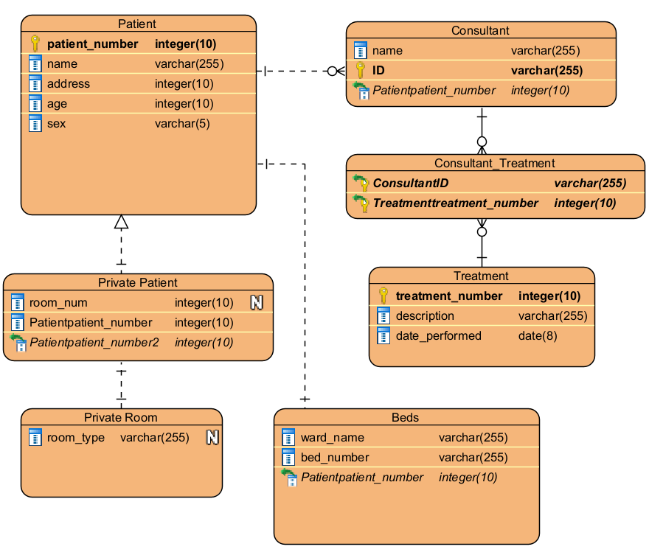

Patient (**patient_number**, name, address, age, sex)

Private Patient (room_num)

FOREIGN KEY patient_number REFERENCES Patient (patient_number)

Private Room (room_type)

Beds (ward_name, bed_number)

FOREIGN KEY patient_number REFERENCES Patient (patient_number)

Consultant (**ID**, name)

FOREIGN KEY patient_number REFERENCES Patient (patient_number)

Treatment (**treatment_number**, description, date_performed)

Consultant_Treatment ()

FOREIGN KEY ID REFERENCES Consultant (ID)

FOREIGN KEY Treatment_number REFERENCES Treatment (treatment_number)